**Readme File:**

1. Please Find ‘DL_project_driver_final.ipynb’ file
2. Step 1: Clone the Repository for pretrained model

```bash

git clone https://github.com/RyanWangZf/Trial2Vec.git

cd Trial2Vec

1. Step 2: We recommend setting up a virtual environment (e.g., with venv or conda) before installation. After that please follow the following to setup the environment

pip install --upgrade pip setuptools wheel

pip install -r requirements.txt || true # if the requirements.txt exists

pip install -e . # install in editable mode for development

1. Step 3 (Optional): Force CPU Mode
2. Please run the #Main Tab to run the final results (results for demo_data)

You are supposed to see the following results

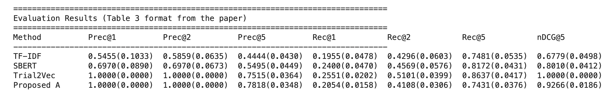

1. For trial2vec embeddings:

Please use the sanity.py file